Project Design Phase-II
Data Flow Diagram & User Stories

Date | 05/03/2026
Team ID | SWTID-2026-2317
Project Name | Product Inventory Management
Maximum Marks | 4 Marks
Data Flow Diagrams:
A Data Flow Diagram (DFD) is a traditional visual representation of the information flows within a system. A neat and clear DFD can depict the right amount of the system requirement graphically. It shows how data enters and leaves the system, what changes the information, and where data is stored.
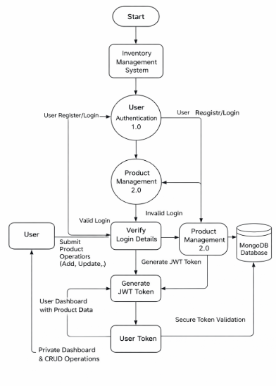
User Stories
Use the below template to list all the user stories for the product.
User Type | User Story Number | User Story / Task | Acceptance Criteria | Priority | Release
Customer (Web User) | USN-1 | As a user, I want to register and log in securely so that I can access my product inventory. | The user can successfully create an account and receive a JWT token after logging in. | High | Sprint-1
Customer (Web User) | USN-2 | As a user, I want to add new products to my inventory so that I can manage my product details. | The product is successfully saved in the database and is visible only to the logged-in user. | High | Sprint-1
Customer (Web User) | USN-3 | As a user, I want to view all my products on the dashboard so that I can monitor my inventory. | The system displays all products associated with the authenticated user when a valid token is provide | High | Sprint-1
Customer (Web User) | USN-4 | As a user, I want to update product details such as price and quantity when inventory | Updated product details are saved successfully and reflected immediately in the dashboard. | Medium | Sprint-2
Customer (Web User) | USN-5 | As a user, I can delete products from my inventory | Product disappears from dashboard after deletion | Medium | Sprint-2
Customer (Web User) | USN-6 | As a user, I can search products by name | Filtered results appear based on keyword | Low | Sprint-2

